Task:
Launch an EC2 instance (Linux and Windows) along with a web server. Then, create an EBS volume of 5 GB, attach it to an EC2 machine (Linux and Windows), and take a snapshot. Finally, create an EBS volume using the taken snapshot.
Step:1: EC2 Dashboard → Click Instances → Launch Instances.
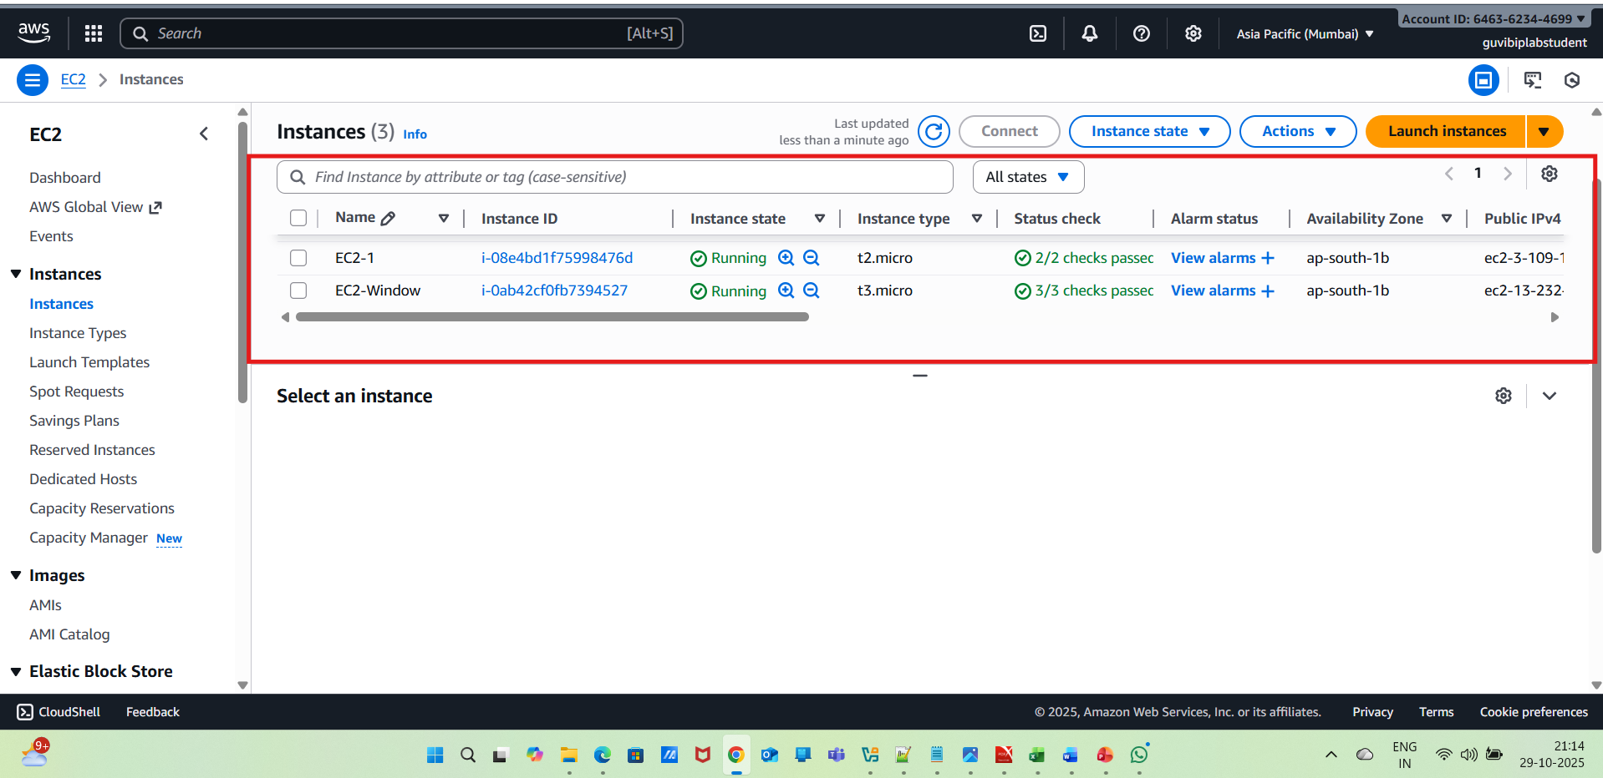
For Linux Instance :
Network settings: Allowed HTTP (port 80) and SSH (port 22).
For Windows instance:
Network settings: Allowed RDP (port 3389) and HTTP (port 80).
Step-2: public ipv4 address ---connect
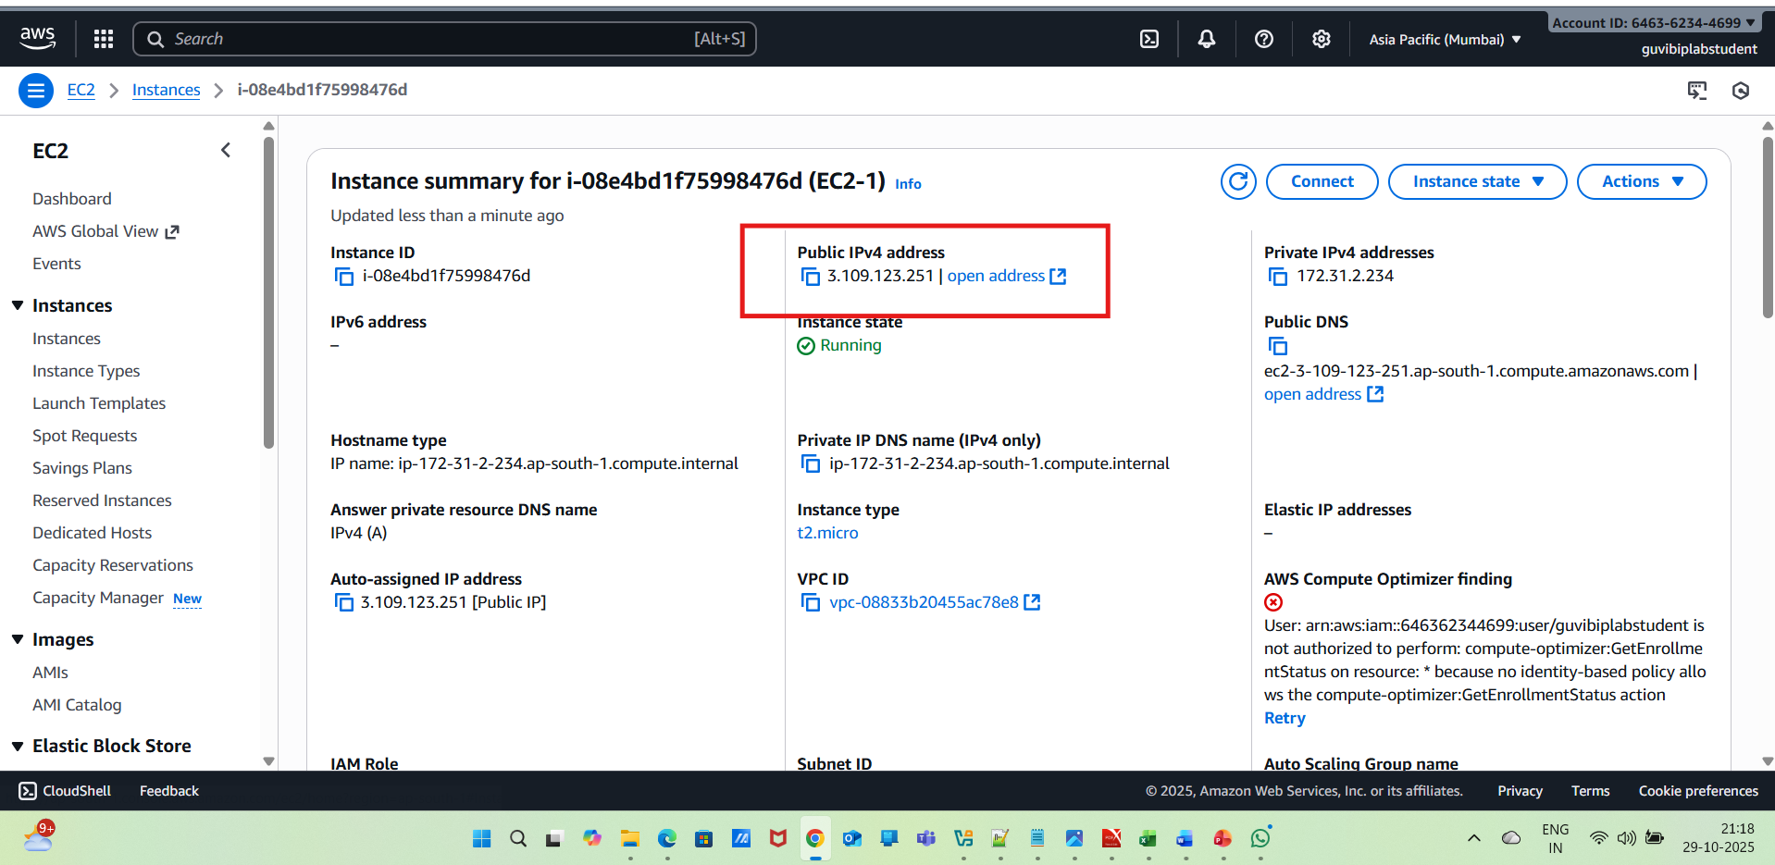
Inside Linux EC2 Terminal used below script to display Welcome to Linux web server
script :
sudo apt update -y
sudo apt install apache2 -y
sudo systemctl start apache2
sudo systemctl status apache2
echo "<h1>Welcome to Linux Web Server</h1>" | sudo tee /var/www/html/index.html
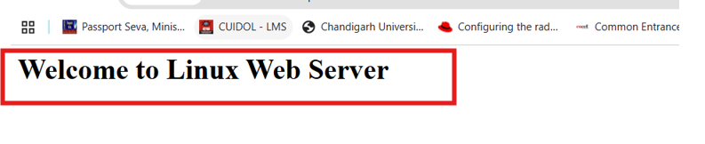
For windows EC2:
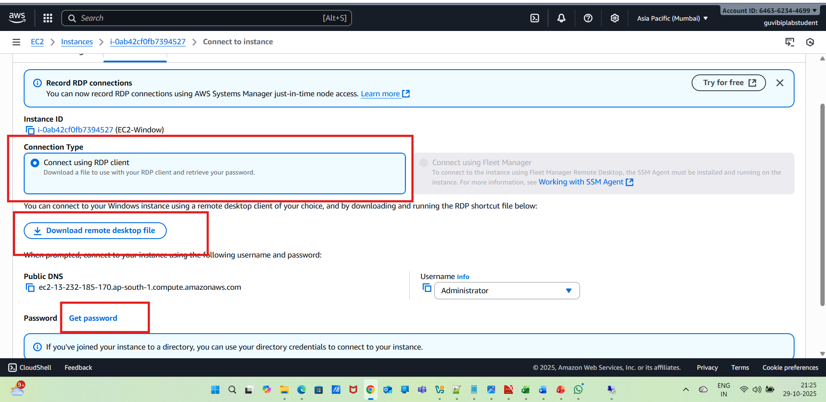
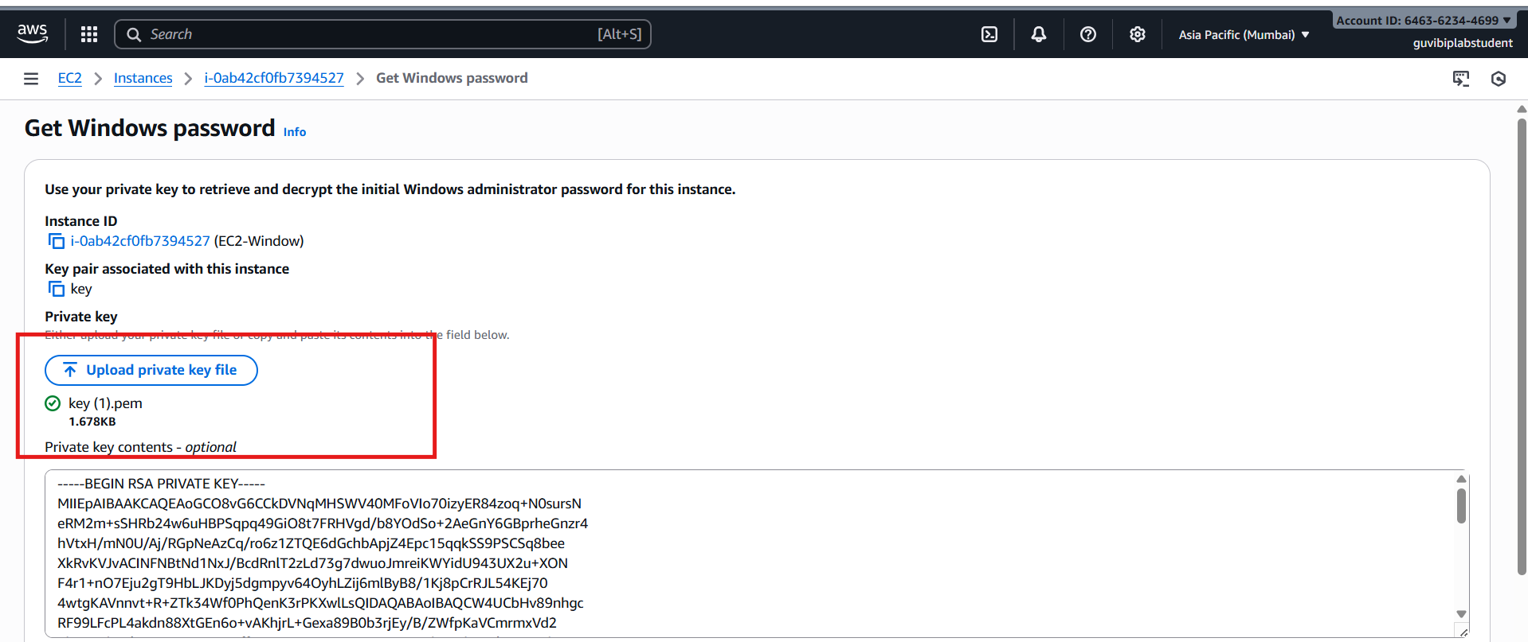
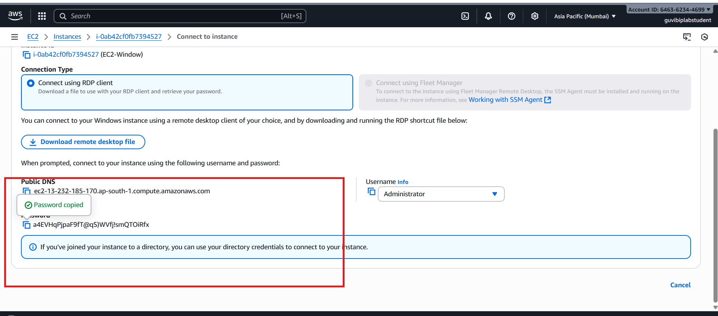
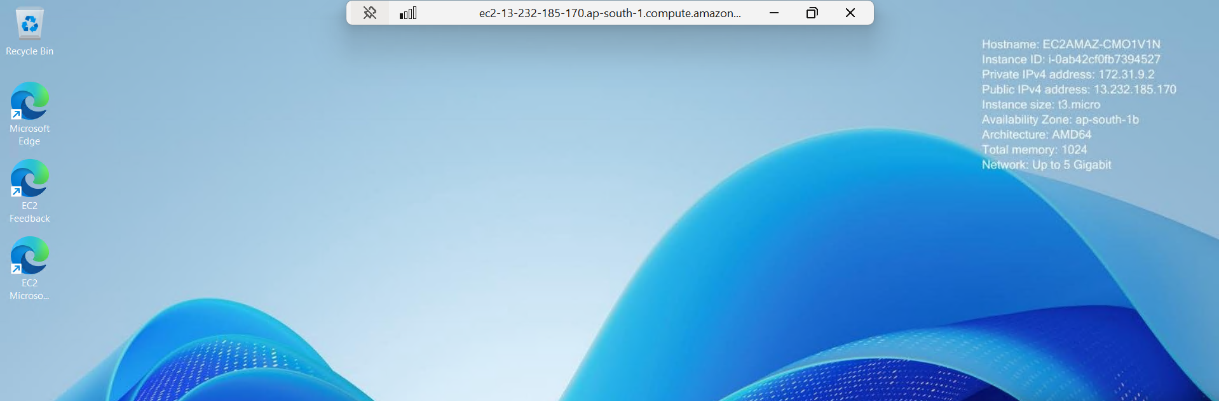
Need to install Windows Server Manager in RDP -open Server Manager → Add Roles and Features → Web Server (IIS)

EBS creation and attaching an EBS Volume:
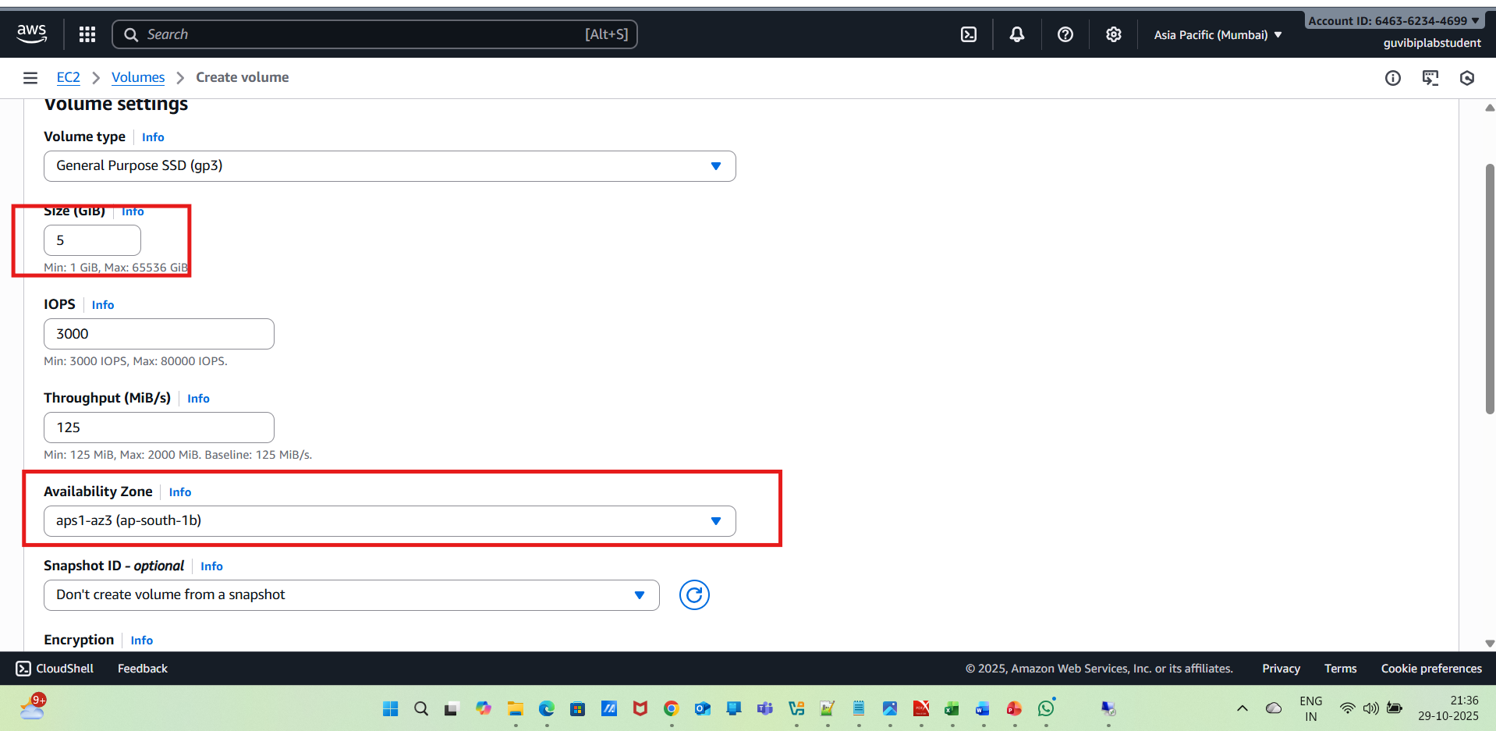
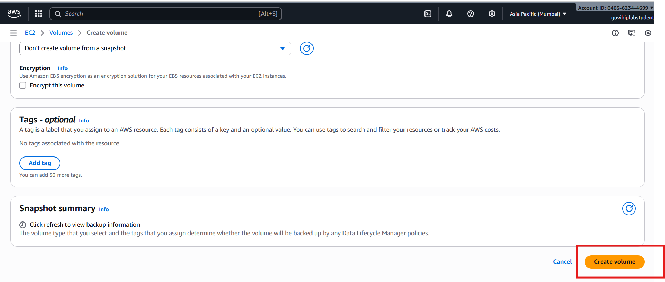
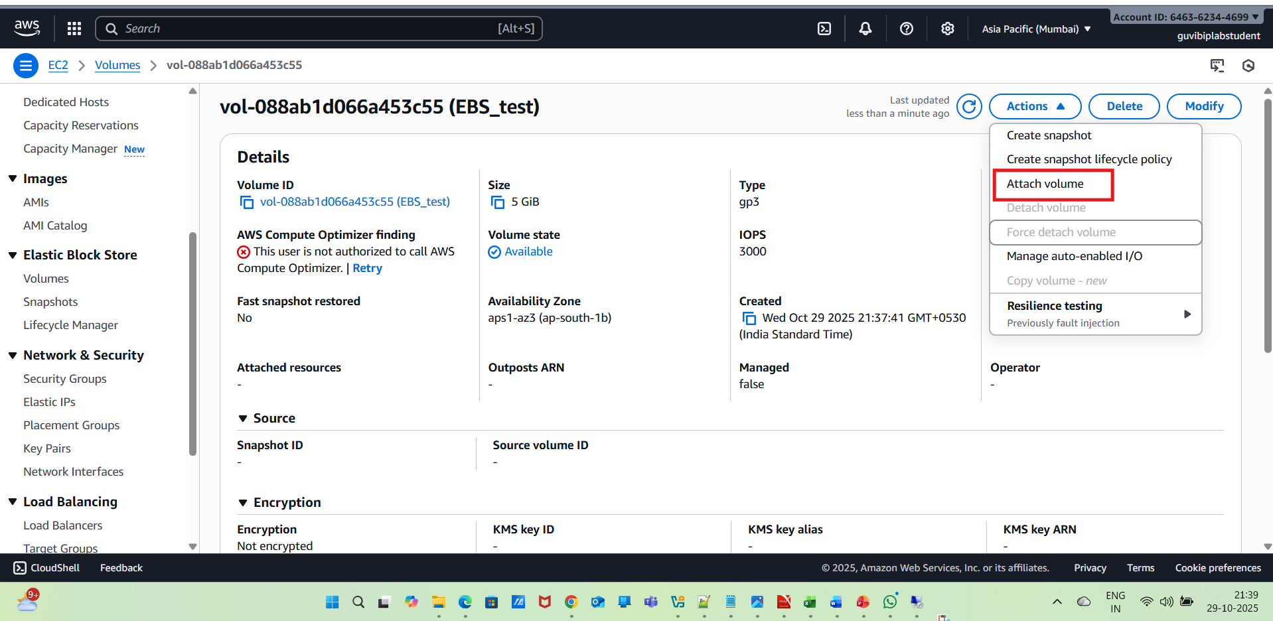
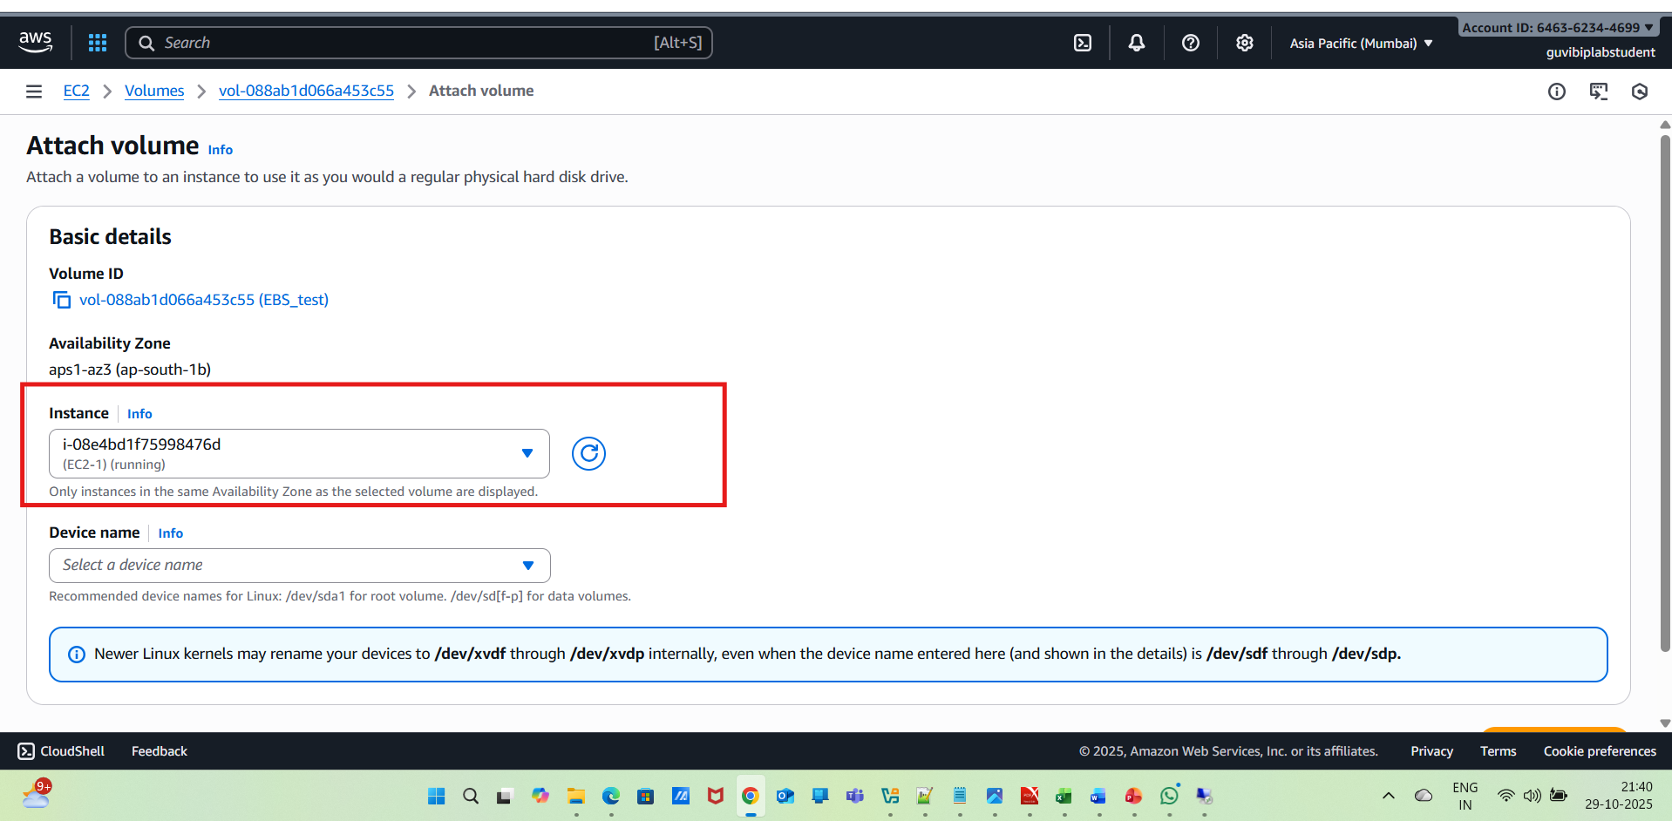
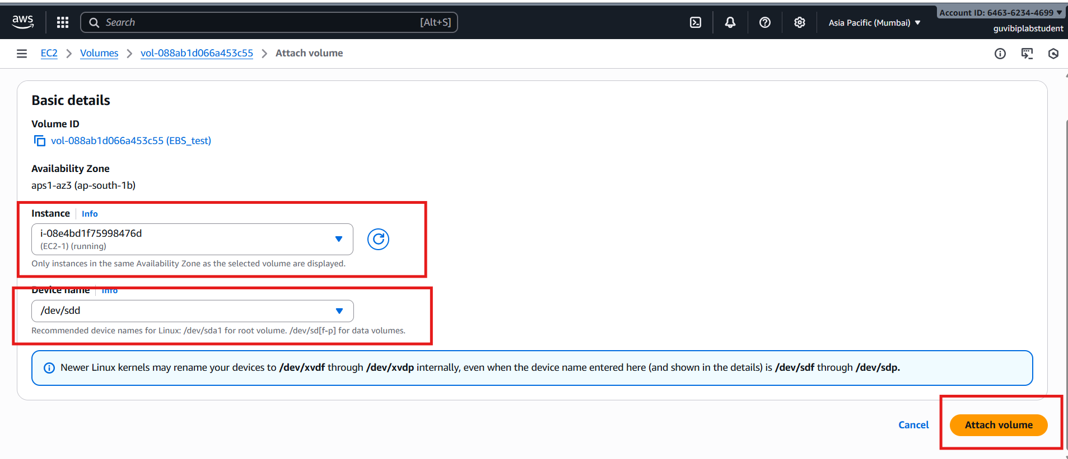
Formatting and Mounting the Volume with EC2-1(Linux):
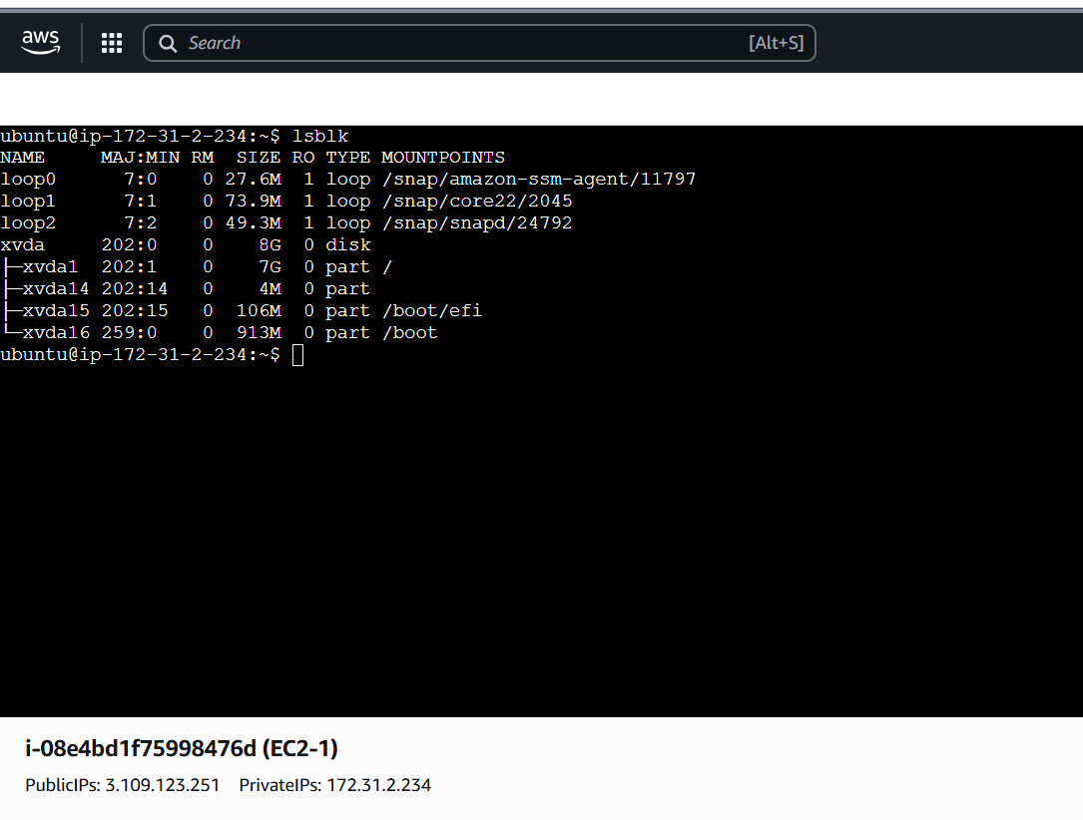
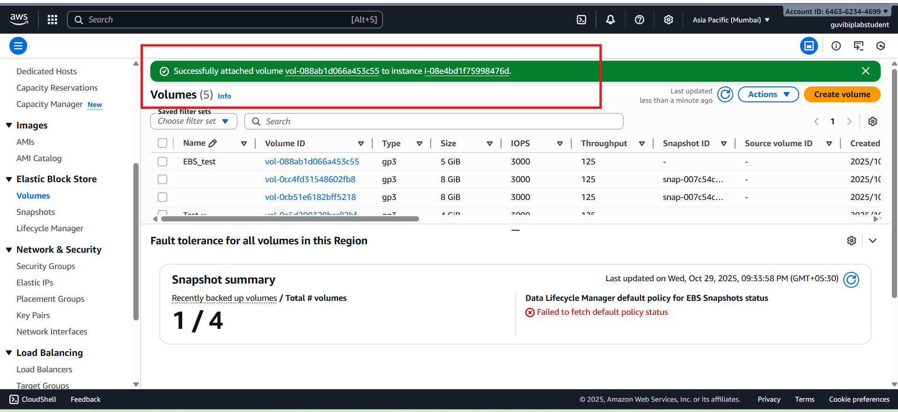
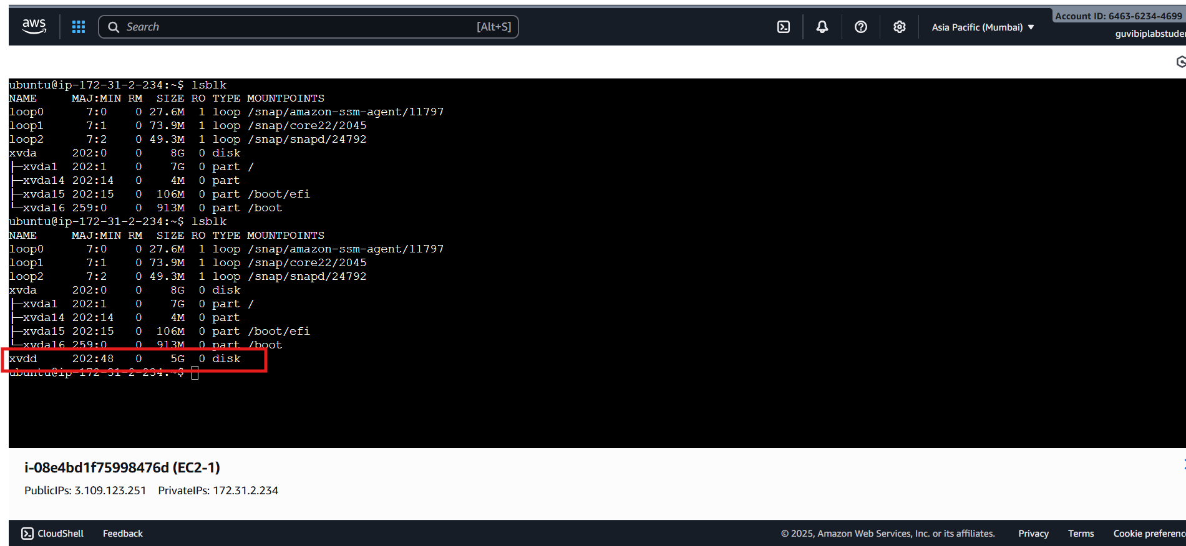
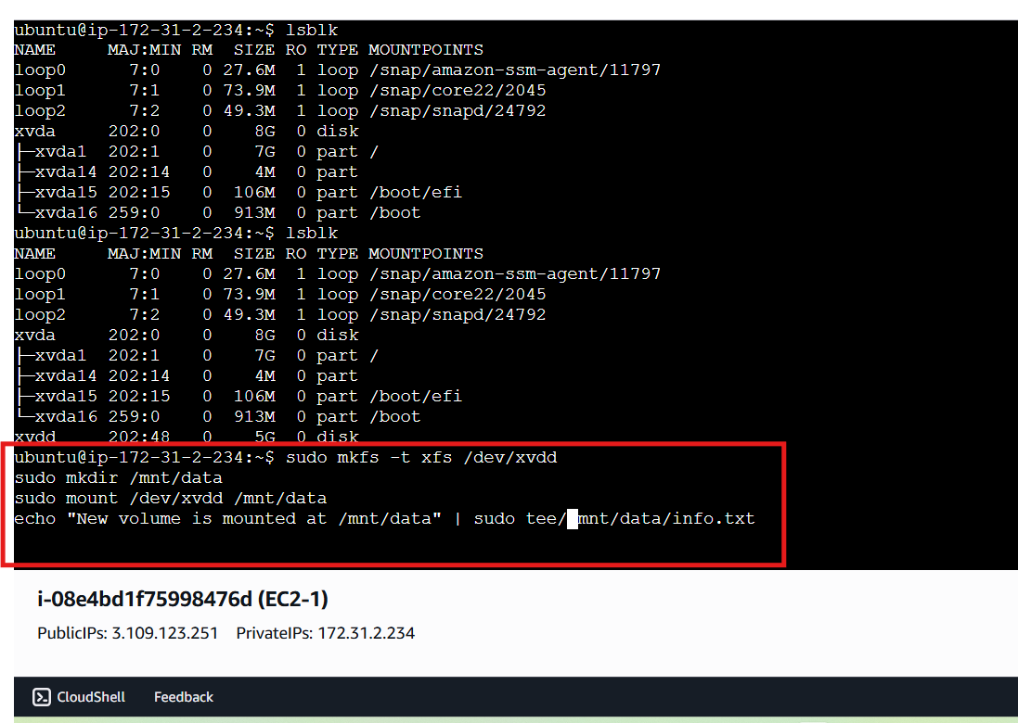
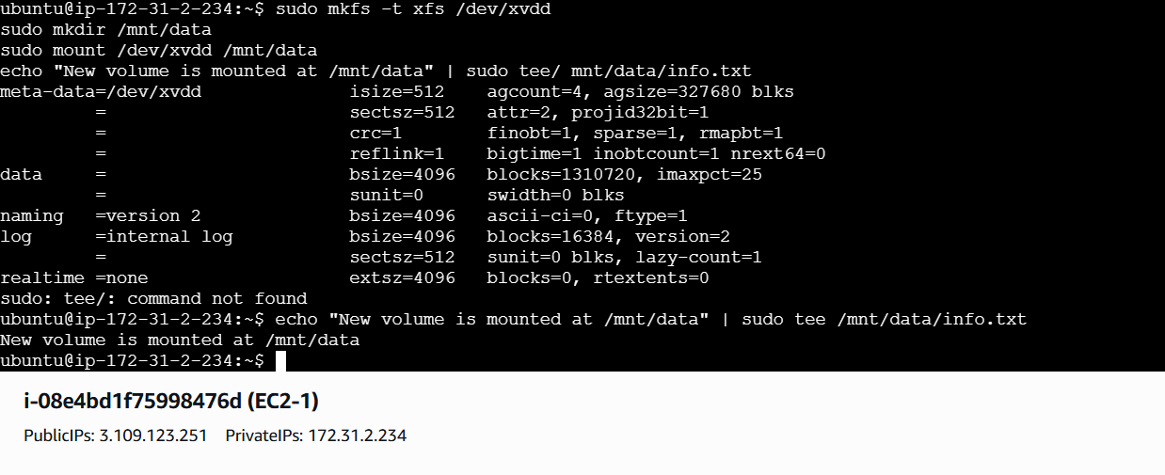
Taking a Snapshot of the Volume:
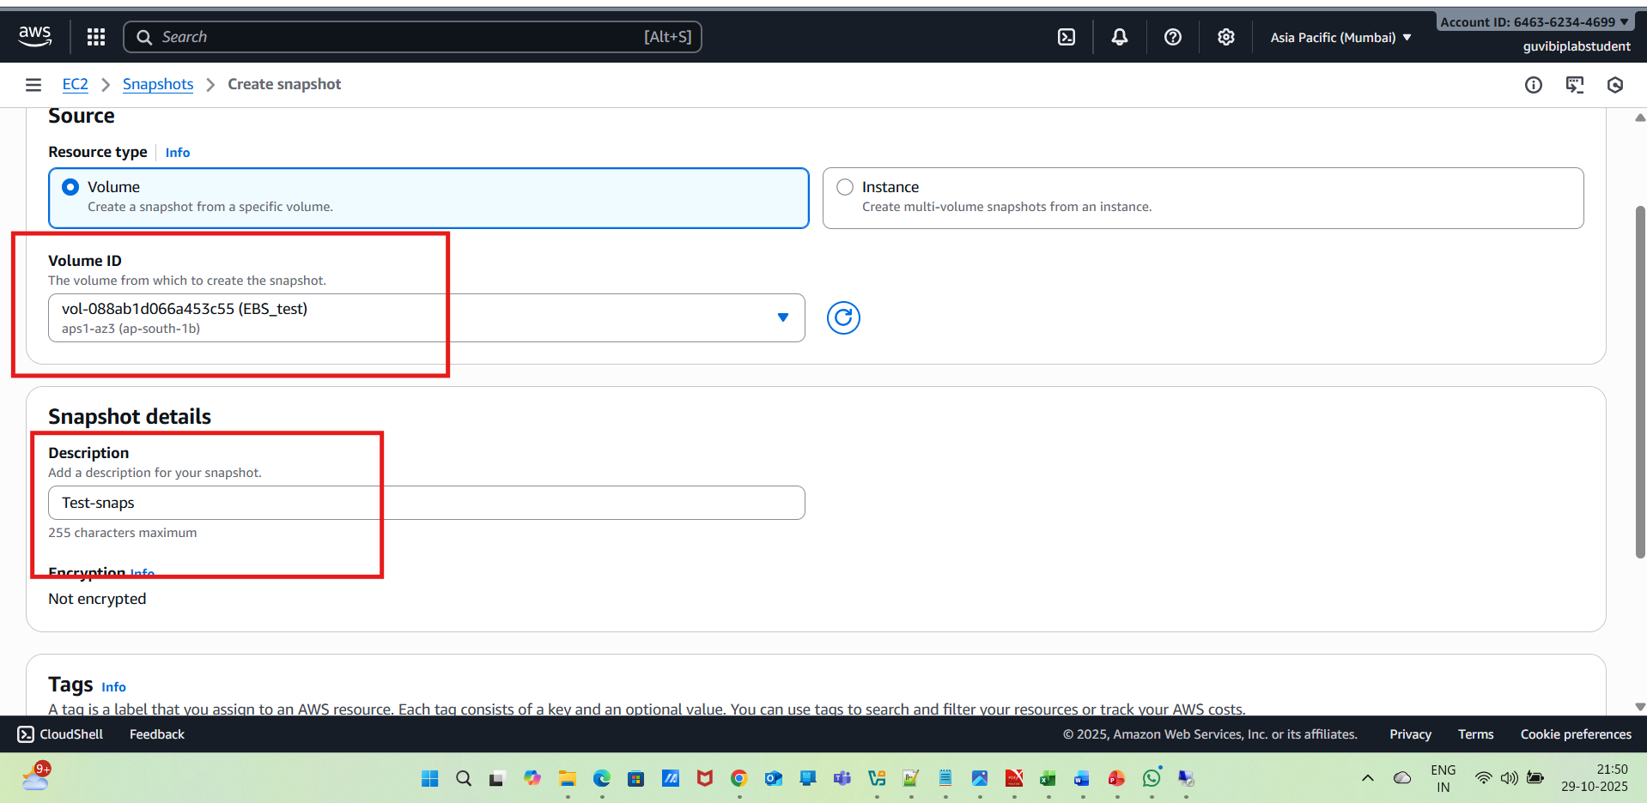
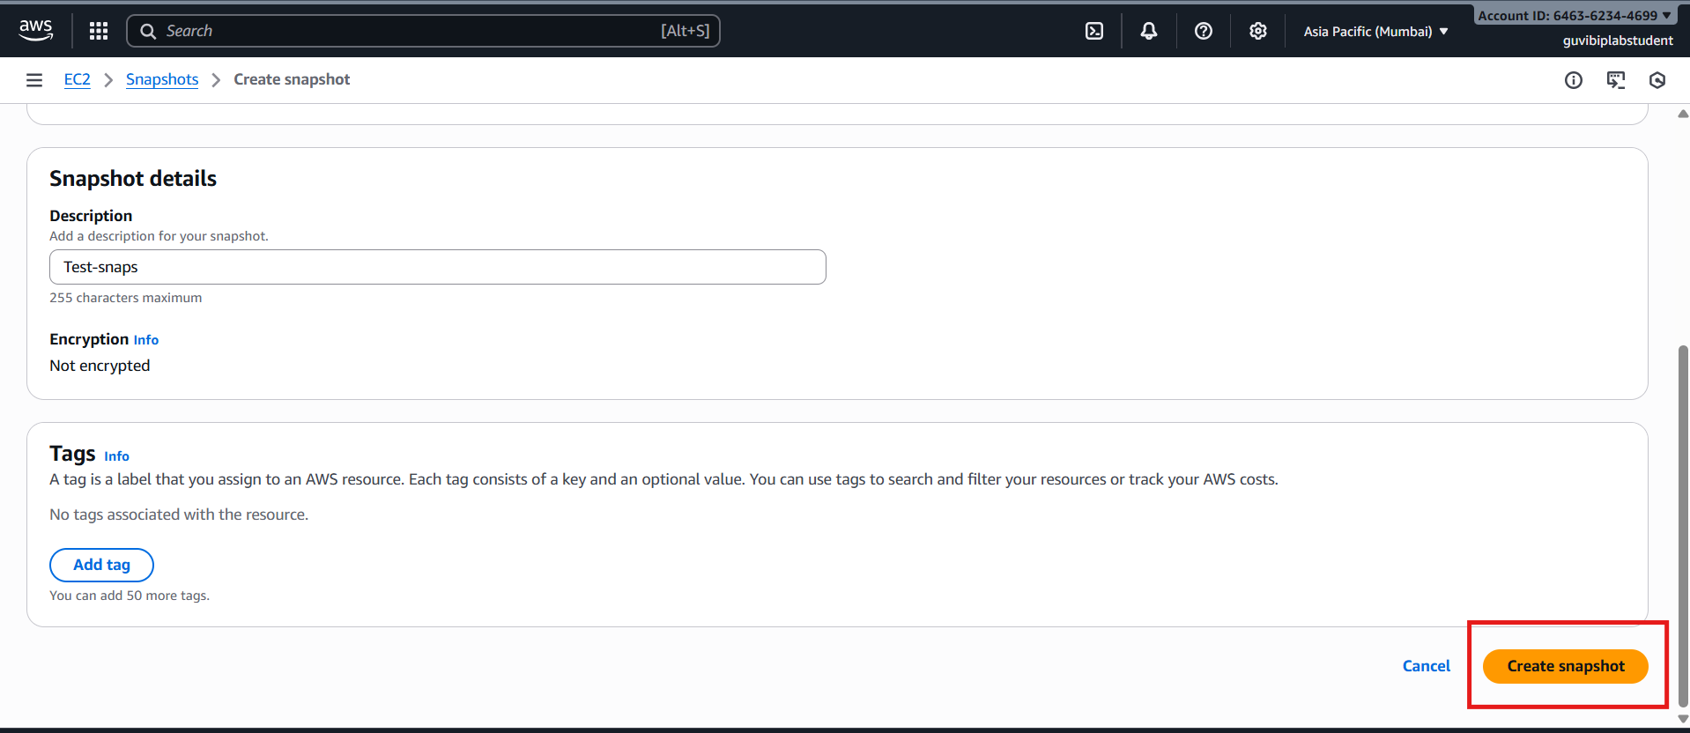
Create a New Volume from the Snapshot:
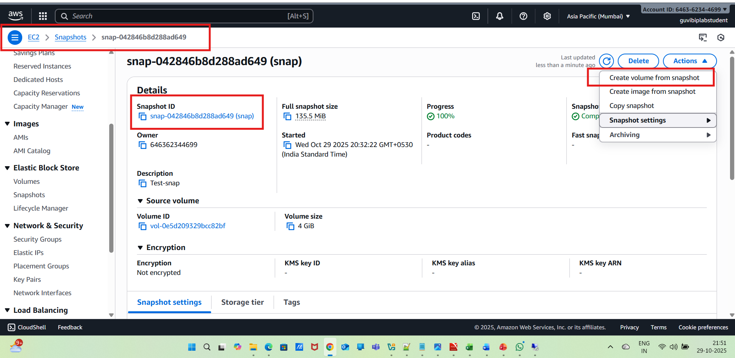
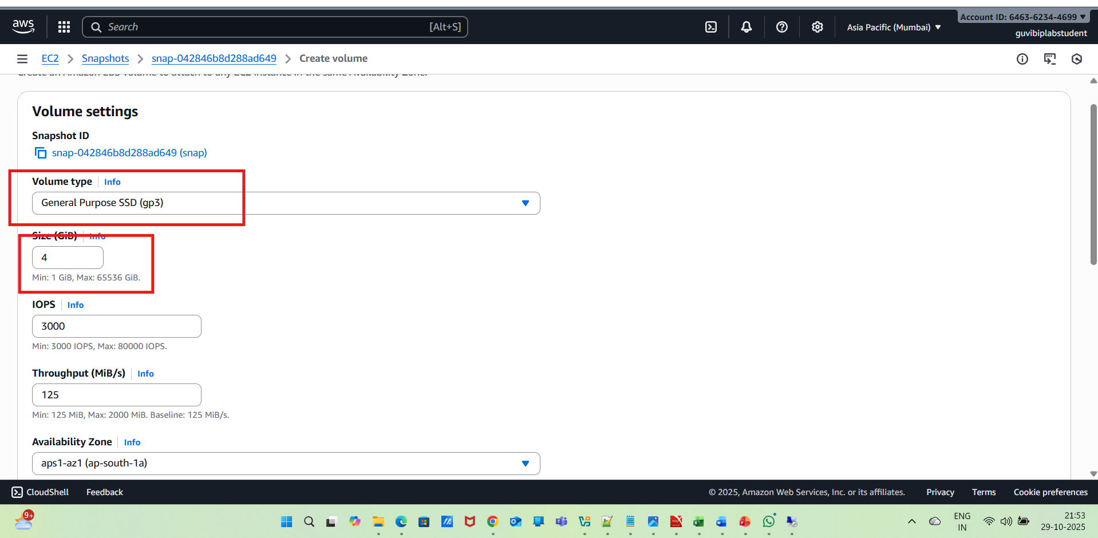
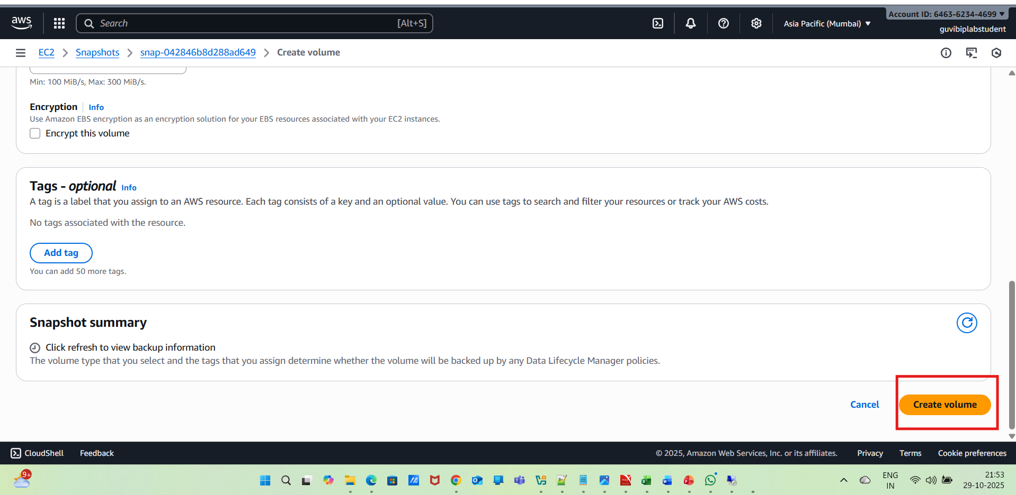
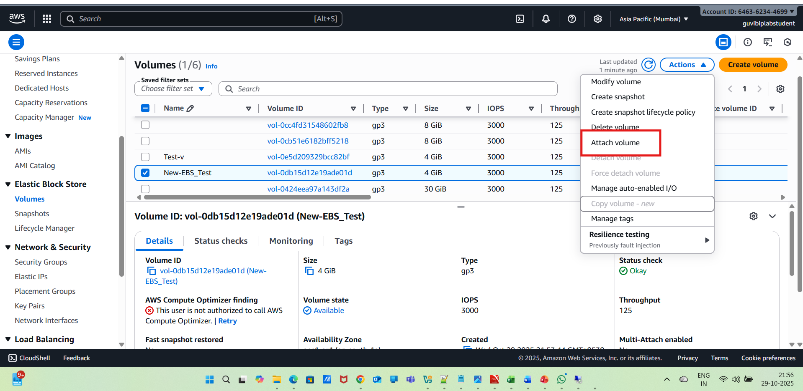
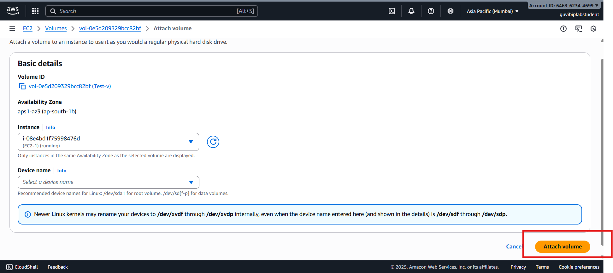
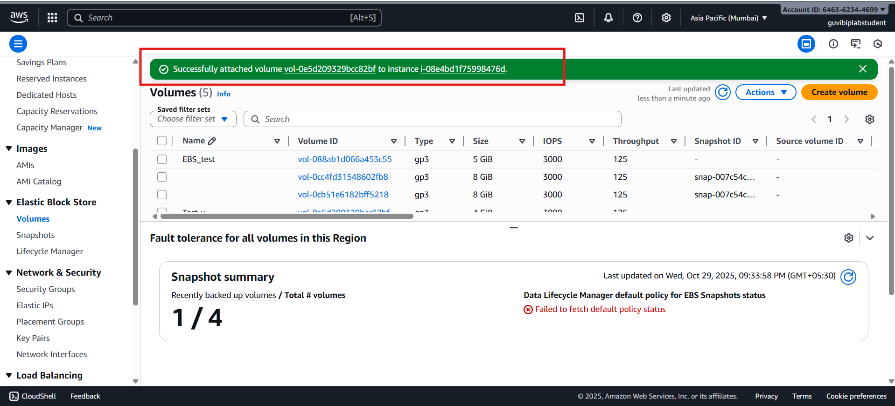
After that, we need to format and mount the 4GB Volume as before step like below
